**CST-105: Exercise 6**

The following exercise assesses your ability to do the following:

* Use and manipulate String objects in a programming solution
* Process arrays using loops
* Utilize arrays to manage collections of data.
* Model tables and grids using 2-dimensional arrays

1. Review the rubric for this assignment before beginning work. Be sure you are familiar with the criteria for successful completion. The rubric link can be found in digital classroom, under the assignment.
2. Write a program that reads text from a file called input.in. Create a 2-dimensional character array that is m * n. Fill the array as follows:
   1. On even numbered rows, fill the row from the leftmost column to the rightmost
   2. On odd numbered rows, fill the row from the rightmost column to the leftmost.
   3. Fill any unused spaces in the 2D array with the ‘*’ character. If you have more characters than space, ignore the excess characters.

Extract the characters from your array in column-major order (pull from column 0 first, then column 1, etc.). Build a new string as you extract the characters. Display the new string.  
  
Here is an example for a 4 * 8 grid and the input string

And the rest is rust and stardust

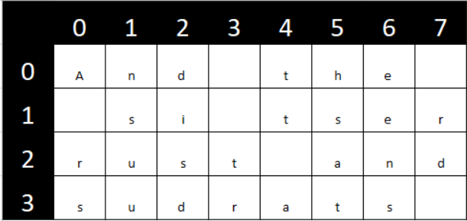  
  
Output string:

  
  
  
Your program should work for any input file and any size grid.

1. Make sure your program *only outputs* *the encrypted string*. Check your solution to ensure that the output string is correct.
2. Make a video of your project. In your video, discuss your code and run your program.
3. Make sure program contains student name and statement of own work. Submit a text file in the digital classroom containing:
4. Your program (.java)
5. A link to your video